 | League City Ladies Auxiliary of the Knights of Columbus | 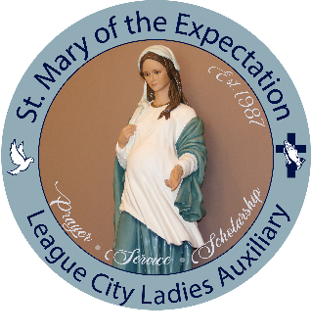

Scholarship Application/Cover Sheet

The League City Ladies Auxiliary provide education scholarships from funds donated by our parish, our fundraising efforts, and the Perusina Endowment Fund.

Requirements Checklist

- Applicant must have completed all 3 sacraments (Baptism, First Communion, and Confirmation).
- Applicant must be a registered member of St. Mary of the Expectation Catholic Church for at least one year.
- An essay of approximately 300 words typed and doubled-spaced entitled:
“At Confirmation you were graced with 7 gifts from the Holy Spirit. Which one means the most to you and how will you share it?”
- List of Church Activities
- List of Community Activities
- List of School Activities

- 4 x 6 “Portrait” Photo of the applicant only. A digital copy of the photo is acceptable as long as it is a high resolution jpeg or png. This photo will be published in the church bulletin.

Incomplete applications will not be considered.
Information on this application must be completed by the applicant

Paper completed applications can be dropped off at the Church office. Questions and completed applications can be emailed to Grace Garza (wograce@msn.com).

All entries must be delivered no later than Thursday, May 7, 2026, at 4:00pm, to the following without exception:

Attn: Grace Garza
League City Ladies Auxiliary
1612 E. Walker Street
League City, Texas 77573
2026 SCHOLARSHIP APPLICATION

Last name |  |  |  |  | First Name |  |  |  | Middle Name
Street Address
City/State/Zip
Home Phone |  |  |  |  |  |  | Mobile Phone
Email
Graduating High School
Father’s/Guardian Last name |  |  |  |  |  | Father’s/Guardian First Name
Street Address
City/State/Zip
Home Phone |  |  |  |  |  |  | Mobile Phone
Email
Mother’s/Guardian Last name |  |  |  |  |  | Mother’s/Guardian First Name
Street Address
City/State/Zip
Home Phone |  |  |  |  |  |  | Mobile Phone
Email
Please list all siblings name and age below
I hereby submit my application for a scholarship to be used while attending the university (college, trade or technical school, etc.) for the 2026 Fall semester listed below.
My intended major is listed below. Applicants are required to attend for minimum of 9 credit hours to be eligible.
Catholic Faith Formation
I have been a member of St. Mary of the Expectation Church since (please provide the year):
Sacrament |  | Parish |  |  |  |  |  |  |  | Year(s)
First Communion
Confirmation

Certified Statement: By signing this application, I understand that failure to meet all the Sacramental requirements listed on the cover page or submitting a late application will result in disregard of this application. I attest that this essay is my own original creation and that the information on the application is all true and correct to the best of my knowledge and belief. I also give my permission for St Mary of the Expectation and League City Ladies Auxiliary to use the provided photo of me for identification and/or for printed and online publication purposes.

Signature (Required) | Date

Submission of this application does not guarantee a scholarship will be awarded to you.

It is an honor to be able to provide scholarships to our St. Mary of the Expectation high school students.

For Office Use Only:

Notifications:
Type | By Whom | Date
Letter
Email
Text
Phone Call

Distribution of Funds
Date | Check # | Amount | Signature

